A Project Report

on

Decoding Urban Soundsapes: A Classification Study

carried out as part of the Deep Learning Lab project
Submitted

by

Sreya Bhattacharya

229309217

Data Science and Engineering

Under the Guidance of
Ms. Harshika Mathur


CONTENTS

Serial No. | Topic | Page No.
1. | Abstract | 3
2. | List Of Figures | 4
3. | Problem Statement | 5
4. | Objectives | 5
5. | Introduction | 6
6. | Literature Review | 7
7. | System Development | 10
8. | Result & Discussion | 14
9. | Conclusion | 16
10. | References | 17

ABSTRACT

City noise. It’s everywhere—cars honking, people talking, machines hammering away. But how do you make sense of it all? That’s exactly what this study aims to do. We trained a computer to listen. Sounds weird, right? But using deep learning—specifically Convolutional Neural Networks (CNNs)—we built a system that can pick out and classify urban sounds. Imagine it like this: the system hears a dog barking, and it knows it’s a dog. A truck engine? It’s got that too. The audio was processed with Mel-frequency Cepstral Coefficients (MFCC) into what’s commonly known as Mel spectrograms, and hence, was transformed into an image. Our final CNN model achieved 91% accuracy on the testing dataset. Why does this matter? Because urban sounds tell us a lot. They can show patterns in noise pollution. Help with city safety.

LIST OF FIGURES

Figure No | Figure Title | Page No
1. | Model Summary | 8
2. | Audio Data Exploration and Analysis | 11
3. | Input Audio Signals | 12
4. | Model Training | 13

Problem statement:

The aim of this project is to process short audio clips to detect the presence of specific urban noises and accurately classify them. This will be achieved by employing deep learning techniques, with a focus on Convolutional Neural Network (CNN) models for sound classification

Objectives:

The objective of the project "Decoding Urban Soundscapes: A Classification Study" is to develop an effective system for analyzing and classifying urban sound environments. It aims to identify and differentiate various sound sources, such as traffic noise, human activities, and natural sounds, to better understand urban acoustics. This study seeks to contribute to noise management, urban planning, and the improvement of urban living conditions by providing insights into the composition and patterns of soundscapes.

Introduction:

This project aims to develop a deep learning-powered audio classifier designed to identify and categorize various sounds. The objective? To analyze audio data and build a model that classifies sounds with precision. By leveraging advancements in deep learning—particularly in speaker recognition—this project seeks to create a dependable tool for effectively analyzing urban audio.
The dataset used is sourced from the Urban Sound Classification Challenge and includes short audio clips of typical city noises, such as children playing, street musicians, and car engines. The process begins with preprocessing these audio samples to extract MFCC (Mel Frequency Cepstral Coefficients), which highlight the distinctive features of each sound. In essence, this project combines innovative technology with real-world applications, providing a practical solution for understanding urban soundscapes.
Literature Review:

Sounds are an integral part of daily life, encompassing activities like conversations, listening to music, and experiencing various environmental noises such as cars passing by, raindrops, and other forms of background sound. The classification of such auditory stimuli is a rapidly evolving field of research, underpinning numerous advanced technologies like automatic speech recognition, security systems, and text-to-speech applications. Continuous advancements in this domain have led to improvements in diverse applications, including video indexing, content-based retrieval, speaker identification, and sound recognition for potential security use cases.

Convolutional Neural Networks (CNNs), which have demonstrated remarkable success in image classification, are being explored for audio classification tasks due to their ability to achieve high accuracy. Unlike images, audio consists of temporal sequences of sounds, making the application of CNNs in this domain a unique and challenging pursuit.

The aim of this project is to develop a deep learning-based audio classification system. The core problem revolves around processing audio data to construct a model capable of accurately categorizing various sounds. Leveraging advancements in deep learning, particularly in speaker identification and recognition, this project strives to enhance the accuracy and usability of such models to assist users effectively.

The dataset utilized for this research is derived from the Urban Sound Classification Challenge, which includes short audio samples representing common urban sounds such as children playing, street music, and car engines. Preprocessing these samples involves extracting Mel-Frequency Cepstral Coefficients (MFCC) features, which serve as inputs to the CNN model. These MFCC features capture the essential characteristics of audio signals, facilitating effective classification.

The neural network processes these inputs and produces a probability distribution vector, indicating the likelihood of the audio sample belonging to each predefined class. The model then predicts the sound's class by selecting the category with the highest probability. This approach exemplifies the application of CNNs in audio classification, showcasing their potential for improving sound recognition in practical scenarios.

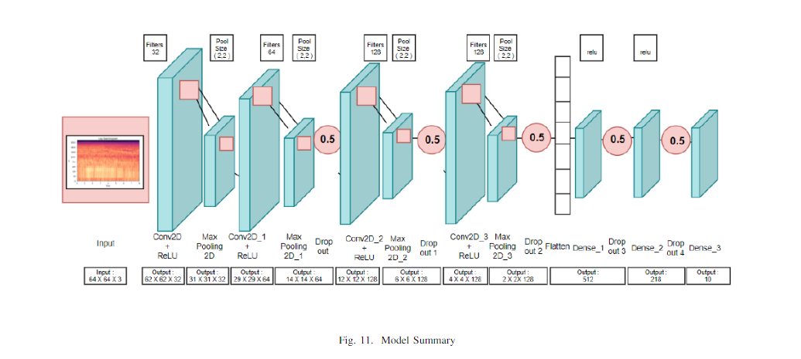

Feature Extraction and Evaluation:

As discussed earlier, we extract Mel-Frequency Cepstral Coefficients (MFCCs) from audio samples and generate mel-spectrograms. This is achieved using the feature. mfcc function from the Librosa library, which processes the audio to produce a 2D matrix of MFCC coefficients. These coefficients represent the essential features of the sound, capturing its frequency and time-domain characteristics. This step is crucial as it simplifies the audio data into a format suitable for feeding into machine learning models for further analysis and classification.

Evaluation Metric:

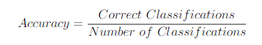

Model Implementation:

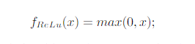

The model includes three convolutional layers, each accompanied by a MaxPooling2D layer. These pooling layers effectively lower the computational load and reduce the number of parameters, simplifying the model's structure. This process not only accelerates training but also helps mitigate overfitting. MaxPooling operates by extracting the highest value from each defined window in the feature map, which is subsequently passed to the output layer.
System Development:

Data Preprocessing:

This log-scaled audio signals was processed using Mel-Frequency Cepstral Coefficients (MFCC), which apply a cosine transform to the log power spectrum on a mel frequency scale. This converts the sound into an image-like spectrogram. This process involves parameters like the Fourier Transform, hop length, and mel coefficients.

CNN Model:

Convolutional Neural Networks (CNNs) are built on Multi-Layer Perceptrons with key differences, such as organized layers with height, width, and depth. Unlike MLPs, nodes in each layer are not fully connected to the next. CNNs work in two main steps: first, a filter slides over the input for feature extraction, storing the results in a feature map, followed by pooling between layers.

Data Exploration and Analysis:

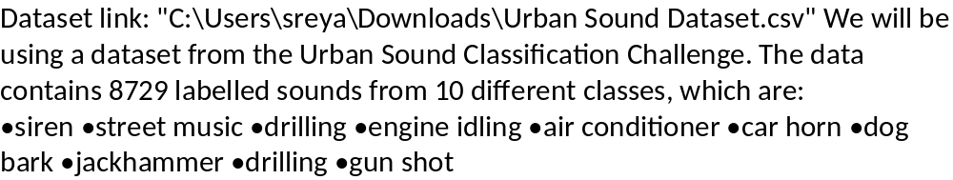

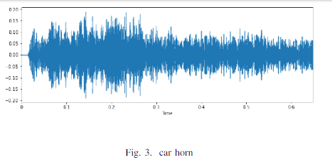
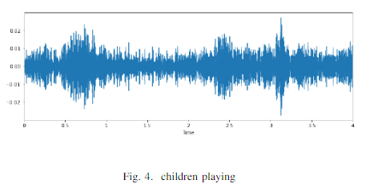
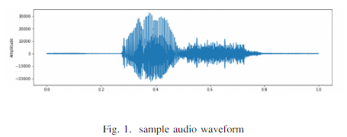
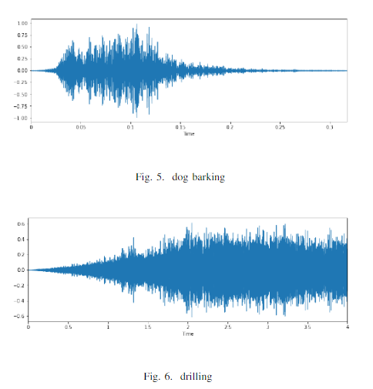
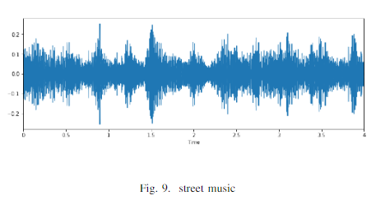

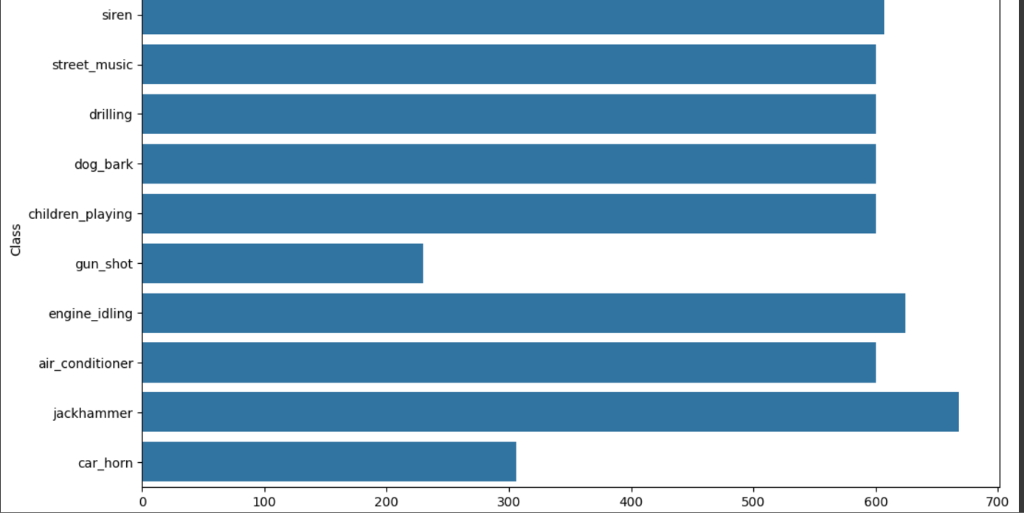

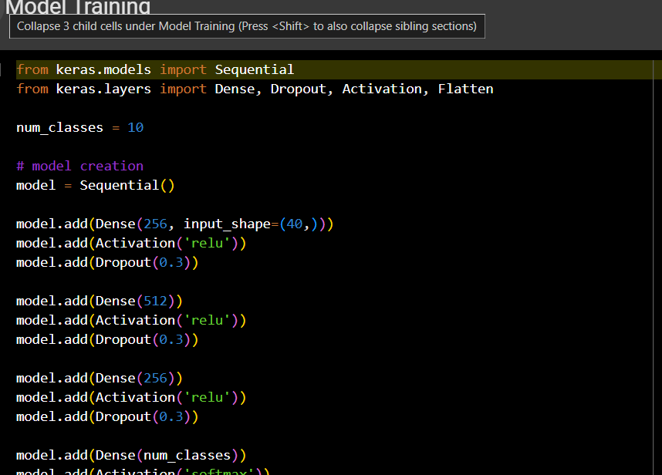
Result & discussion:

We are able to achieve a classification accuracy score of 93% on the testing dataset with an error rate of 7%.
93%

Accuracy
The trained model achieved a classification accuracy of 93% on the test set, demonstrating its effectiveness in detecting urban sounds.

7%

Error Rate
The model's error rate was just 7%, indicating a low level of misclassification of urban sounds.

The model achieved a 91% accuracy score on the testing data, demonstrating strong performance when classifying .wav files of a few seconds in duration. However, its effectiveness in real-time audio processing and practical, real-world scenarios remains uncertain. We did not explore how variables such as background noise, echoes, volume, or the prominence of the sample might influence the model's performance.
Conclusion:

Insights:
We successfully classified 10 different classes of audio samples from the given dataset by constructing a sequential7-layer CNN model. We used MFCC to generate mel-spectrograms and used them as an input for the model. We can conclude that CNN can be as effective of an algorithm for audio classification as it is for image classification.

Limitations:
While the model performs well, there is still room for improvement in handling complex, overlapping sounds and expanding the diversity of the training data.

Future Work:
Evaluate the model’s performance with real-time audio. Train the model using real-world data by incorporating various background noises, adjusting sound volumes, and adding echoes. Explore alternative feature extraction methods, such as different types of spectrograms.
Reference:

- M. Smales, “Classifying Urban sounds using Deep Learn-ing,” 2018. [Online]. Available: https://github.com/mikesmales/Udacity ML Capstone/blob/master/Report/Repo
- Practice Problem: Urban Sound Classification, 2017.[Online]. Available:https://datahack.analyticsvidhya.com/contest/practice-problemurban-
- B. W. M. W. R. W. Jisheng Bai, Chen Chen, “Urban Sound Tagging WithFig.14. Model Loss Multi-Feature Fusion System,” Detection and Classification of Acoustic Scenes and
- “Feature learning with deep scattering for urban sound analysis, ”in 2015 23rd European Signal Processing Conference (EUSIPCO),2015, pp. 724–728.
- K. Jaiswal and D. Kalpesh bhai Patel, “Sound classification using convolutional neural networks,” in 2018 IEEE International Conference on Cloud Computing in Emerging Markets (CCEM), 2018, pp. 81–84.

